**Lab4 AI Report**

Made by:

**Ahmad Said Nouh (7086)**

**Hossam Eldin Ahmed Eissa (6747)**

**Hussein Mourad Kassem (6729)**

**Ahmed Alaa Tawfik (6842)**

Contents

Preprocessed: 5

(1e-3): 5

Confusion Matrix: 5

Graph: 5

(5e-4): 6

Confusion Matrix: 6

Graphs: 6

(1e-4): 6

Confusion Matrix: 6

Graphs: 6

(5e-5): 7

Confusion Matrix: 7

Graphs: 7

(1e-5): 7

Confusion Matrix: 7

Graphs: 7

(5e-6): 8

Confusion Matrix: 8

Graphs: 8

(1e-6): 9

Confusion Matrix: 9

Graphs: 9

Raw: 10

(1e-3): 10

Confusion Matrix: 10

Graphs: 10

(5e-4): 10

Confusion Matrix: 10

Graphs: 10

(1e-4): 11

Confusion Matrix: 11

Graphs: 11

(5e-5): 11

Confusion Matrix: 11

Graphs: 11

(1e-5): 12

Confusion Matrix: 12

Graphs: 12

(5e-6): 13

Confusion Matrix: 13

Graphs: 13

(1e-6): 14

Confusion Matrix: 14

Graphs: 14

Bonus: 15

(1e-6), processed, decoder (/4): 15

Confusion Matrix: 15

Graphs: 15

(1e-6), processed, decoder (/8): 16

Confusion Matrix: 16

Graphs: 16

(1e-6), processed, encoder + decoder (/4): 17

Confusion Matrix: 17

Graphs: 17

(1e-6), processed, encoder + decoder (/8): 18

Confusion Matrix: 18

Graphs: 18

(1e-6), raw, decoder (/4): 19

Confusion Matrix: 19

Graphs: 19

Comments: 20

|  |  |  |
| --- | --- | --- |
|  | Predicted (n) | Predicted (p) |
| Actual (n) | TN | FP |
| Actual (p) | FN | TP |

# Preprocessed:

## (1e-3):

### Confusion Matrix:

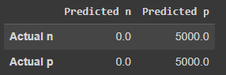

Test Accuracy: 0.500

Percision : 0.0

Sensitivity (Recall) : nan

Specifity : 0.5

F1 Score = nan

### Graph:

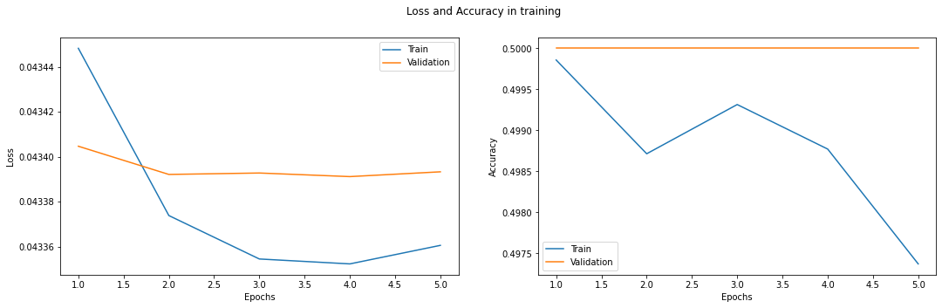

## (5e-4):

### Confusion Matrix:

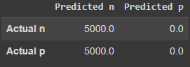

Test Accuracy: 0.500

Percision : 1.0

Sensitivity (Recall) : 0.5

Specifity : nan

F1 Score = 0.6666666666666666

### Graphs:

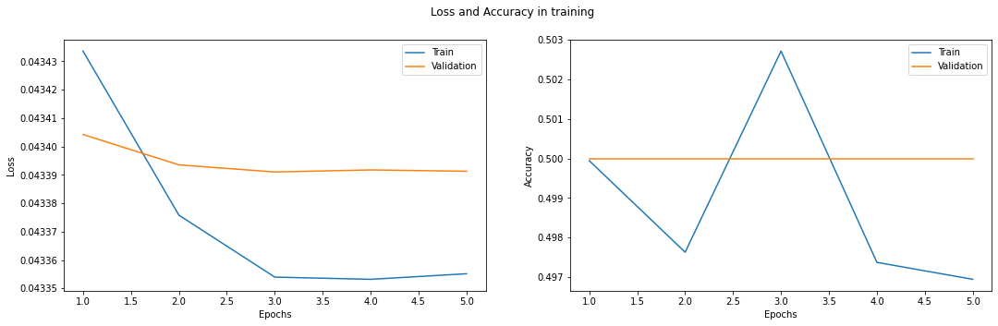

## (1e-4):

### Confusion Matrix:

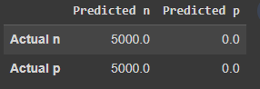

Test Accuracy: 0.500

Percision : 1.0

Sensitivity (Recall) : 0.5

Specifity : nan

F1 Score = 0.6666666666666666

### Graphs:

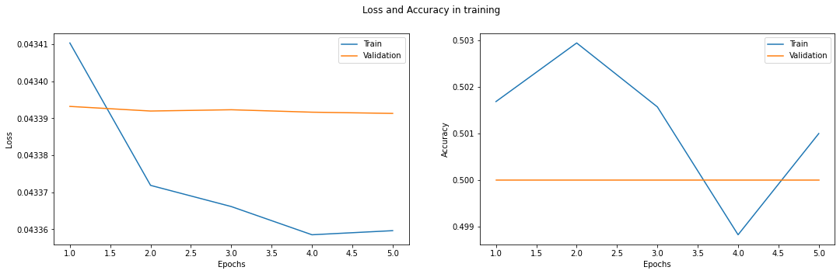

## (5e-5):

### Confusion Matrix:

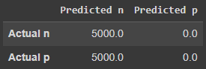

Test Accuracy: 0.500

Percision : 1.0

Sensitivity (Recall) : 0.5

Specifity : nan

F1 Score = 0.6666666666666666

### Graphs:

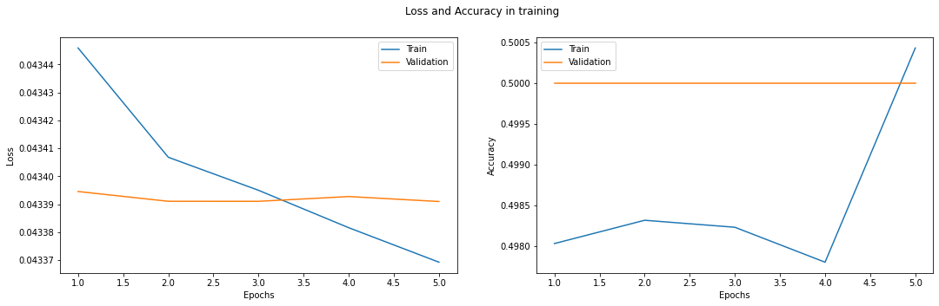

## (1e-5):

### Confusion Matrix:

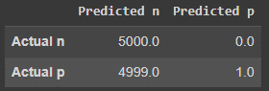

Test Accuracy: 0.500

Percision : 1.0

Sensitivity (Recall) : 0.5000500050005

Specifity : 1.0

F1 Score = 0.6667111140742716

### Graphs:

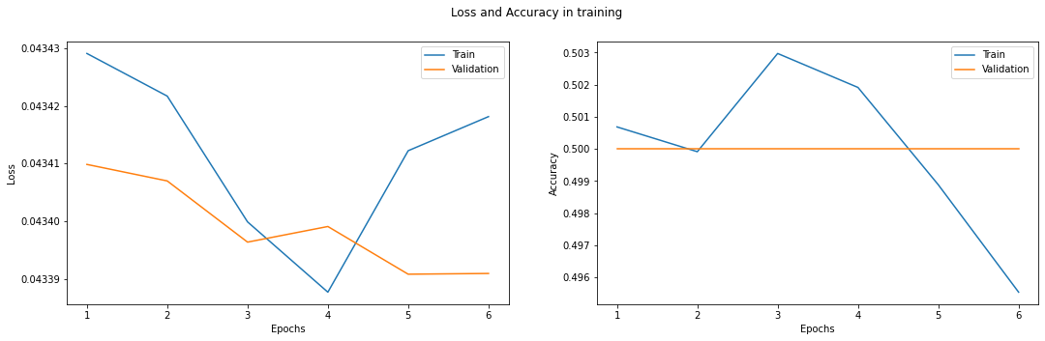

## (5e-6):

### Confusion Matrix:

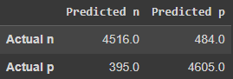

Test Accuracy: 0.912

Percision : 0.9032

Sensitivity (Recall) : 0.9195683160252495

Specifity : 0.9048929062684221

F1 Score = 0.9113106649177681

### Graphs:

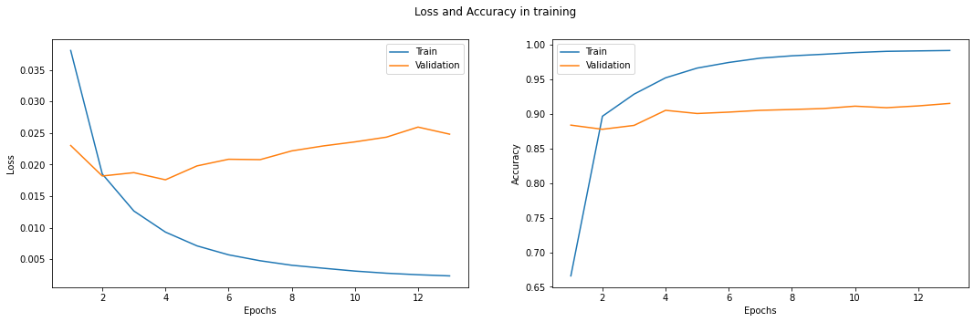

## (1e-6):

### Confusion Matrix:

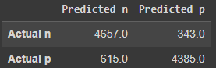

Test Accuracy: 0.904

Percision : 0.9314

Sensitivity (Recall) : 0.8833459787556904

Specifity : 0.9274534686971235

F1 Score = 0.9067367601246106

### Graphs:

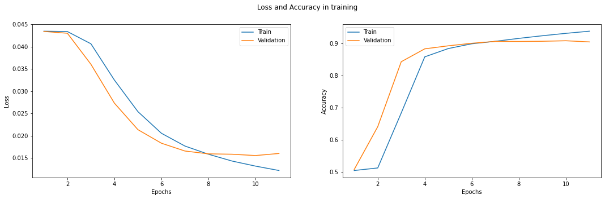

# Raw:

## (1e-3):

### Confusion Matrix:

Test Accuracy: 0.500

Percision : 1.0

Sensitivity (Recall) : 0.5

Specifity : nan

F1 Score = 0.6666666666666666

Confusion Matrix :

[[5000. 0.]

[5000. 0.]]

### Graphs:

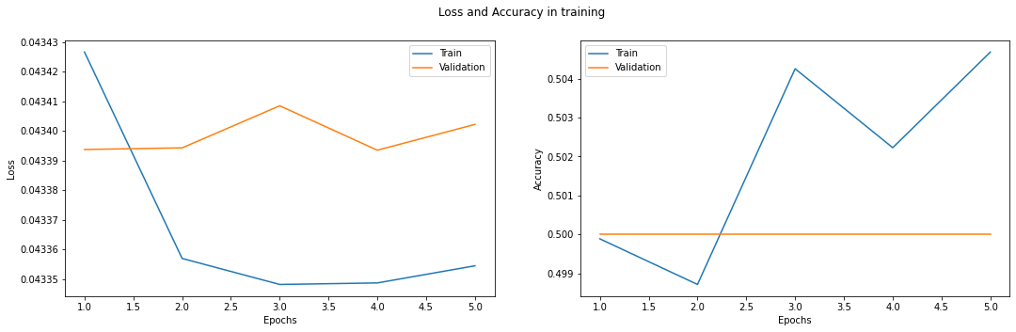

## (5e-4):

### Confusion Matrix:

Test Accuracy: 0.500

Percision : 0.0

Sensitivity (Recall) : nan

Specifity : 0.5

F1 Score = nan

Confusion Matrix :

[[ 0. 5000.]

[ 0. 5000.]

### Graphs:

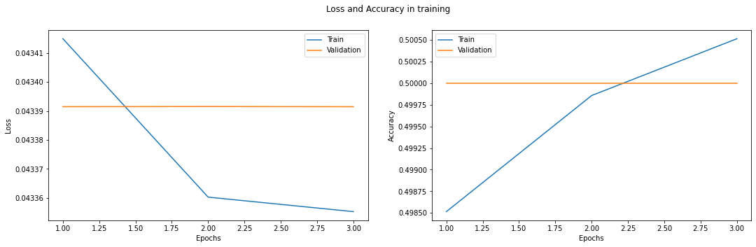

## (1e-4):

### Confusion Matrix:

Test Accuracy: 0.500

Percision : 1.0

Sensitivity (Recall) : 0.5

Specifity : nan

F1 Score = 0.6666666666666666

Confusion Matrix :

[[5000. 0.]

[5000. 0.]]

### Graphs:

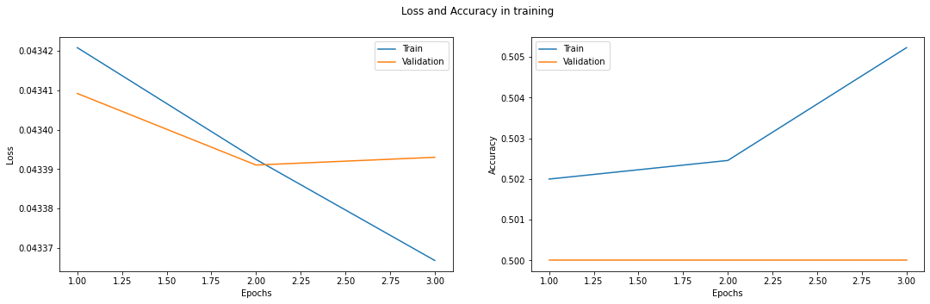

## (5e-5):

### Confusion Matrix:

Test Accuracy: 0.500

Percision : 1.0

Sensitivity (Recall) : 0.5

Specifity : nan

F1 Score = 0.6666666666666666

Confusion Matrix :

[[5000. 0.]

[5000. 0.]]

### Graphs:

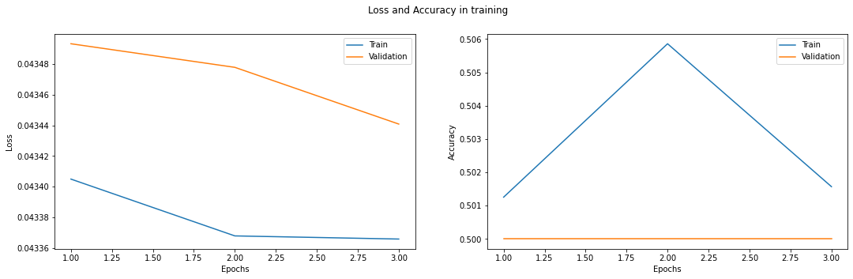

## (1e-5):

### Confusion Matrix:

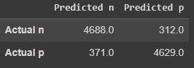

Test Accuracy: 0.932

Percision : 0.9376

Sensitivity (Recall) : 0.9266653488831785

Specifity : 0.9368548876745598

F1 Score = 0.9321006064221096

### Graphs:

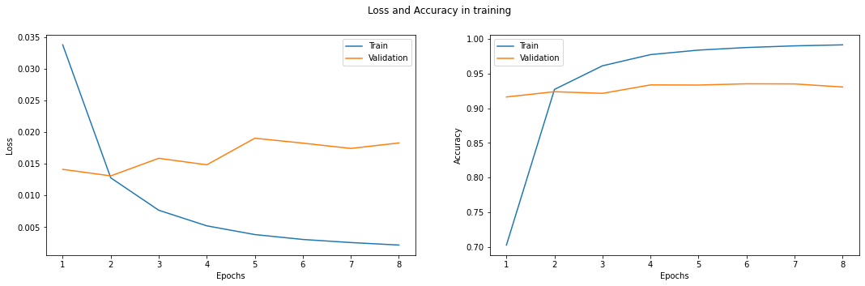

## (5e-6):

### Confusion Matrix:

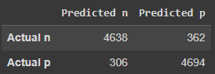

Test Accuracy: 0.933

Percision : 0.9276

Sensitivity (Recall) : 0.9381067961165048

Specifity : 0.9284018987341772

F1 Score = 0.9328238133547868

### Graphs:

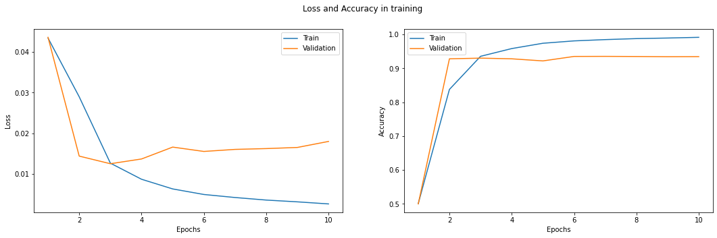

## (1e-6):

### Confusion Matrix:

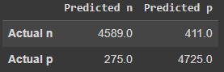

Test Accuracy: 0.931

Percision : 0.9178

Sensitivity (Recall) : 0.9434621710526315

Specifity : 0.9199766355140186

F1 Score = 0.9304541768045417

### Graphs:

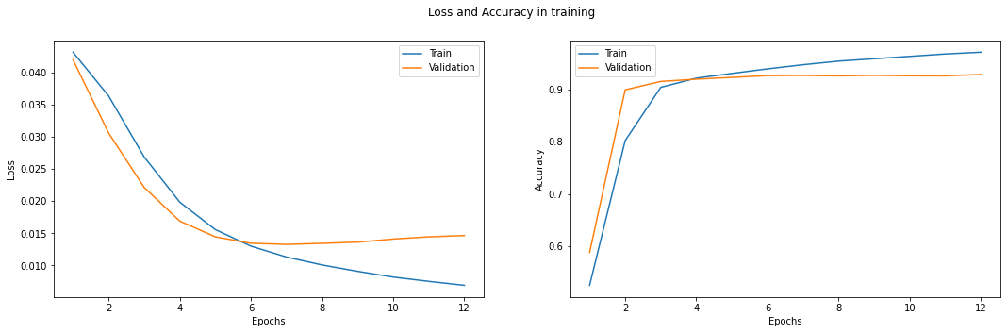

# Bonus:

## (1e-6), processed, decoder (/4):

### Confusion Matrix:

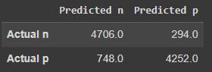

Test Accuracy: 0.896

Percision : 0.9412

Sensitivity (Recall) : 0.8628529519618628

Specifity : 0.9353277606687197

F1 Score = 0.9003252343600535

### Graphs:

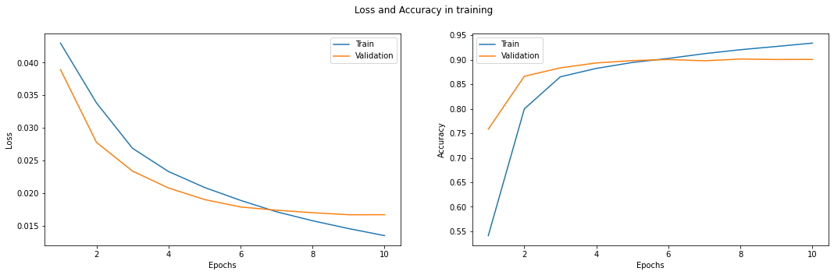

## (1e-6), processed, decoder (/8):

### Confusion Matrix:

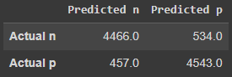

Test Accuracy: 0.901

Percision : 0.8932

Sensitivity (Recall) : 0.9071704245378834

Specifity : 0.8948197754579476

F1 Score = 0.9001310087675098

### Graphs:

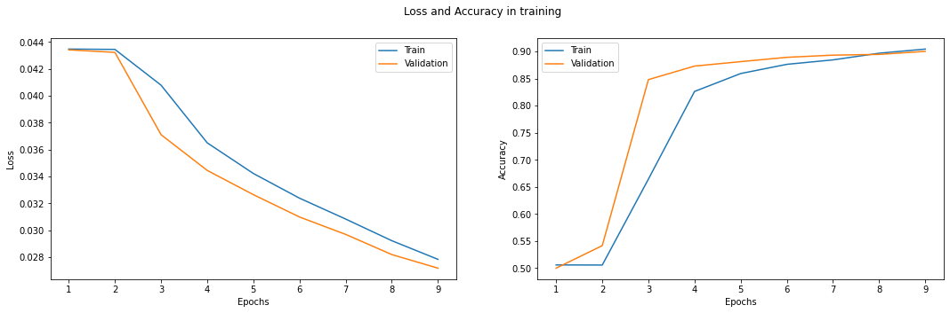

## (1e-6), processed, encoder + decoder (/4):

### Confusion Matrix:

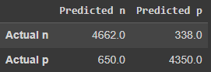

Test Accuracy: 0.901

Percision : 0.9324

Sensitivity (Recall) : 0.8776355421686747

Specifity : 0.927901023890785

F1 Score = 0.904189294026377

### Graphs:

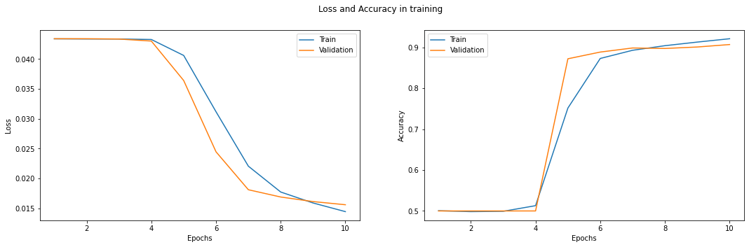

## (1e-6), processed, encoder + decoder (/8):

### Confusion Matrix:

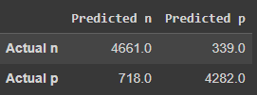

Test Accuracy: 0.894

Percision : 0.9322

Sensitivity (Recall) : 0.866517940137572

Specifity : 0.9266392555723869

F1 Score = 0.898159745640235

### Graphs:

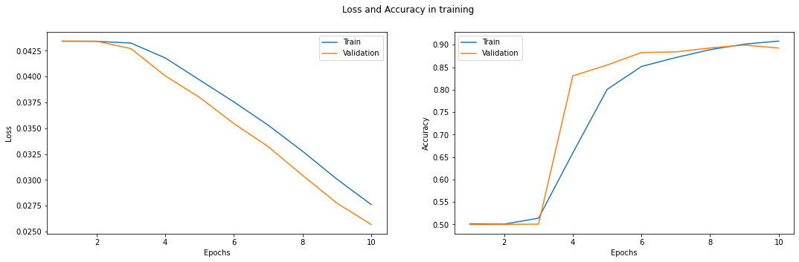

## (1e-6), raw, decoder (/4):

### Confusion Matrix:

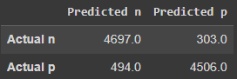

Test Accuracy: 0.920

Percision : 0.9394

Sensitivity (Recall) : 0.9048352918512811

Specifity : 0.9369931378665003

F1 Score = 0.921793739574134

### Graphs:

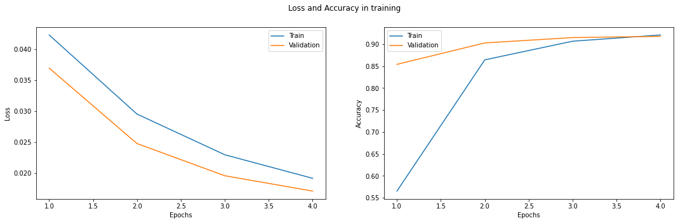

# Comments:

It is clear that all models trained using the raw data performed better than the models that trained using the preprocessed data.

There are several reasons why our NLP BERT-based model may have performed better without preprocessing your dataset. One possibility is that preprocessing steps such as lowercasing, stemming, and stopword removal may have removed important information from the text that the model needs to make accurate predictions. Additionally, BERT is trained on a large corpus of unprocessed text, so it may be better suited to handle raw text than preprocessed text. Another possible reason is that our preprocessing steps may have introduced errors into the dataset that hindered the model's performance. Finally, it could be the case that our dataset is small and the added noise from the preprocessing steps caused overfitting. Therefore, it's always a good idea to try both preprocessed and unprocessed data to see which works better for a specific task.

More detailed analysis for several potential reasons why our model may have performed better without preprocessing the IMDB dataset:

The dataset is already cleaned and preprocessed: The IMDB dataset is a popular dataset and has been used in many studies, it's likely that it's already cleaned and preprocessed to some extent.

Preprocessing steps introduced errors: Preprocessing steps such as lowercasing, stemming, and stopword removal may have introduced errors into the dataset that hindered the model's performance.

Preprocessing removed important information: Preprocessing steps may have removed important information from the text that the model needs to make accurate predictions.

The dataset is large: BERT is trained on a large corpus of text and it can handle the noise and the out of vocabulary words well.

Regularization: The preprocessing may have removed some of the noise that the model relies on as a regularization technique.

It's always a good practice to try both preprocessed and unprocessed data to see which works better for a specific task. And also fine-tune our preprocessing steps to see which one works best.